### 1. Create a free aws account by clicking on "Create Free Account" <http://aws.amazon.com>

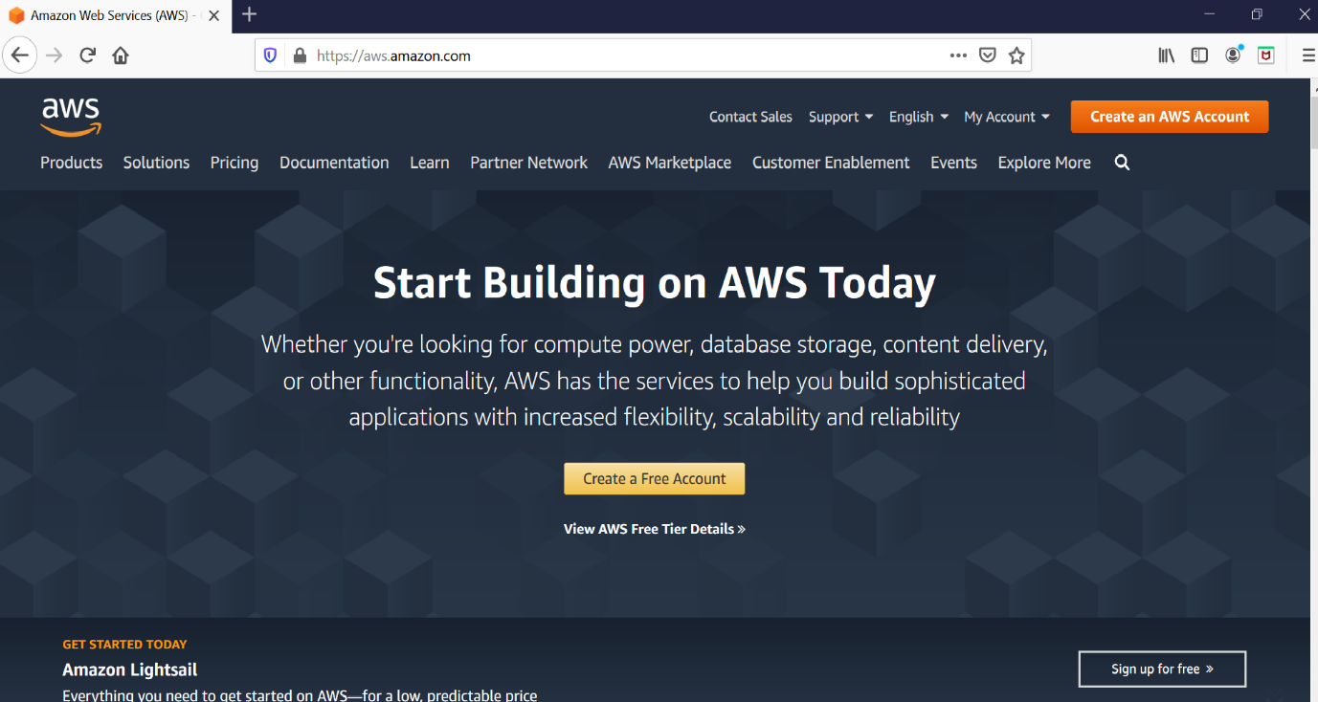

### 2. Fill your details to create an account. Details required are Email address and account name of your choice.

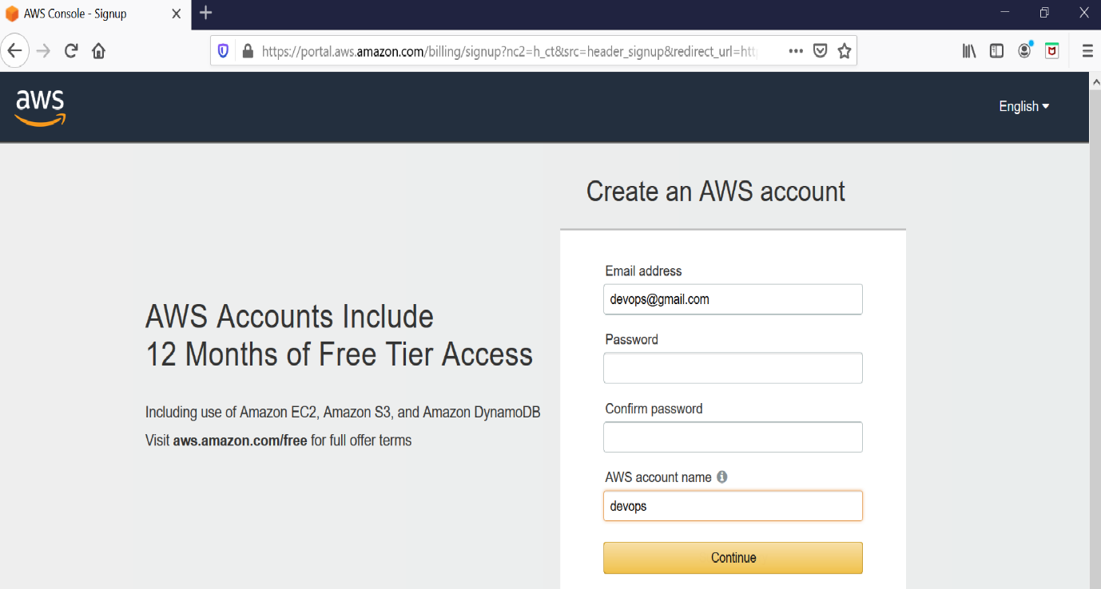

### 3. After submitting the data you will be taken to SignUp form which requires more details.

**Select Account Type as `Personal`.Your address and Mobile number. (Need to provide a valid mobile number, You will receive a call in further setup)**

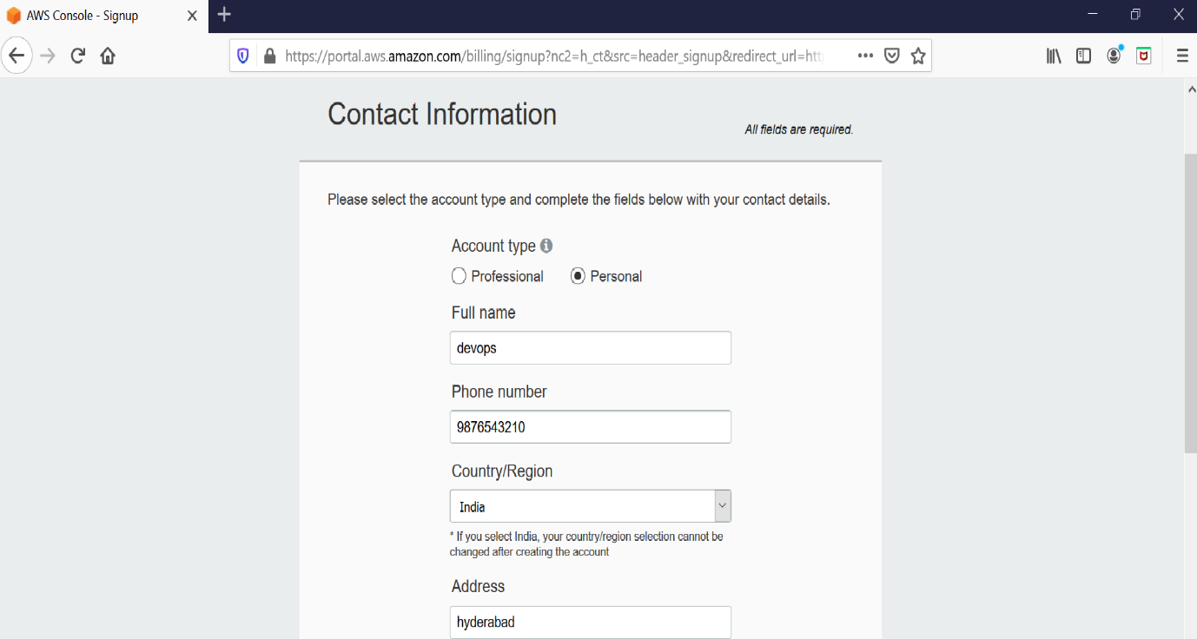

### 4. Next you will be prompt to provide the credit card details. So proceed by providing the details.

**Provide credit/debit card details.**

**Select PAN number as NO**

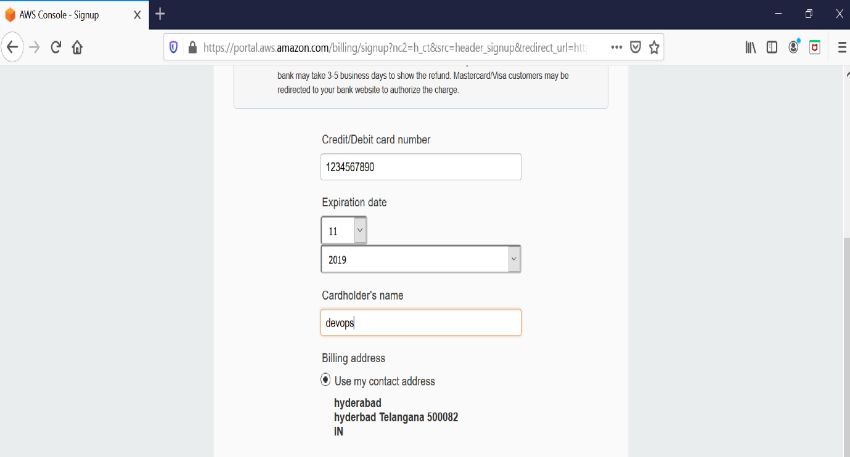

### 5. You will be redirected to your bank payment portal to provide OTP and after that select the plan as Basic.

### 6. Once your account is completed use the following link

<https://aws.amazon.com/console/> **and sign in to the console**.

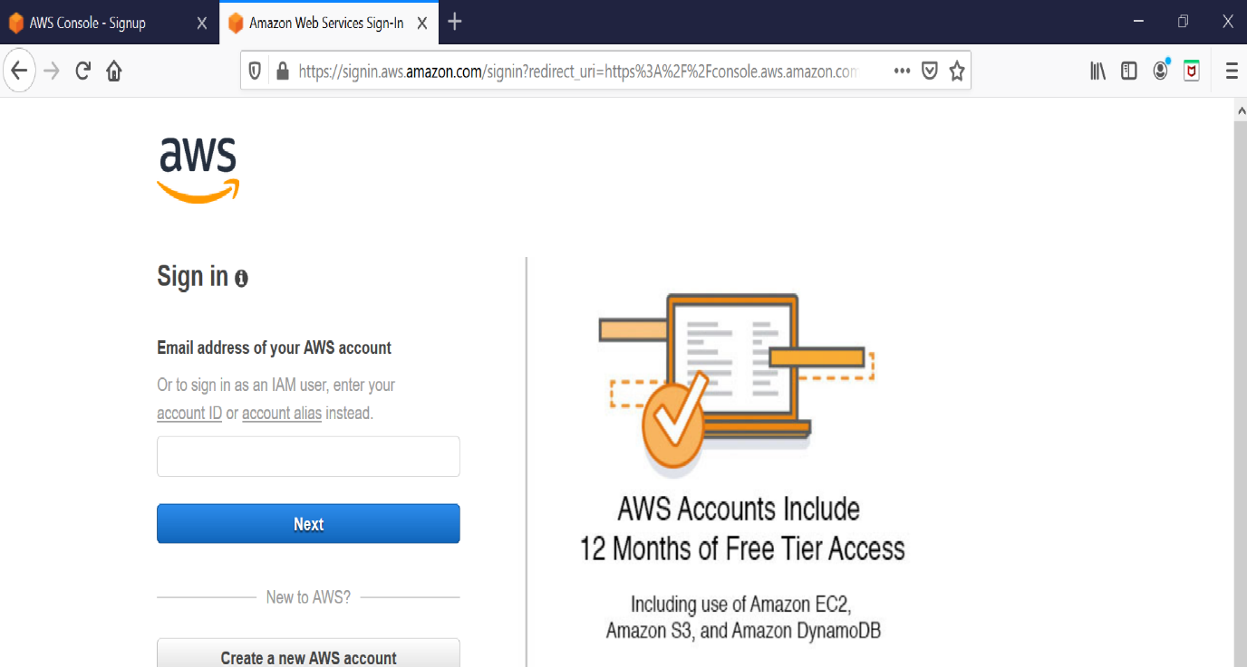

**7. In the search box, search EC2 and click on it.**

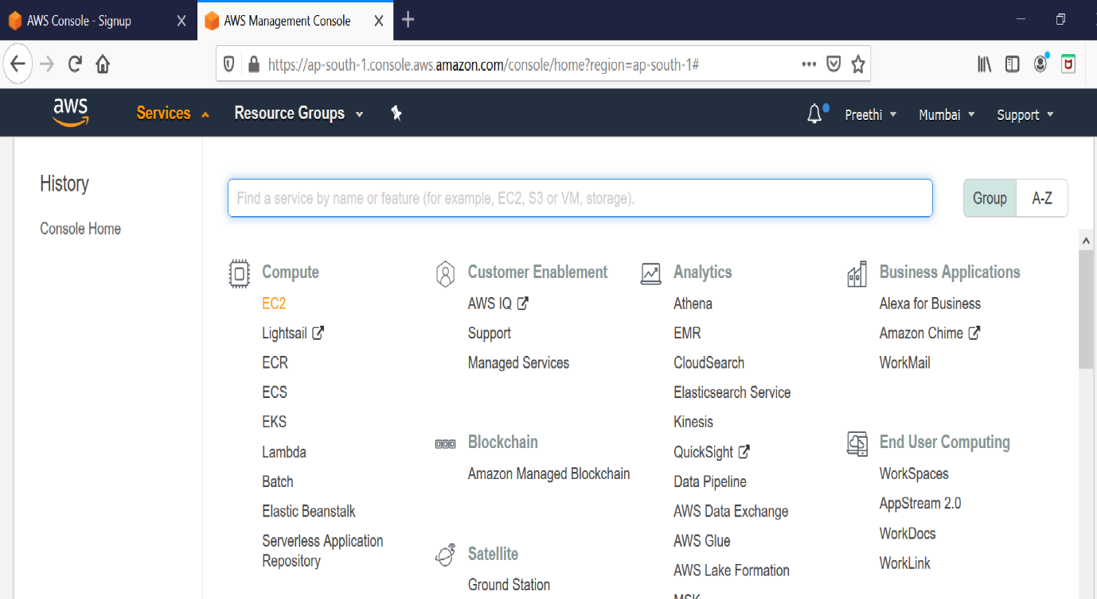

**8. Click on launch Instance**.

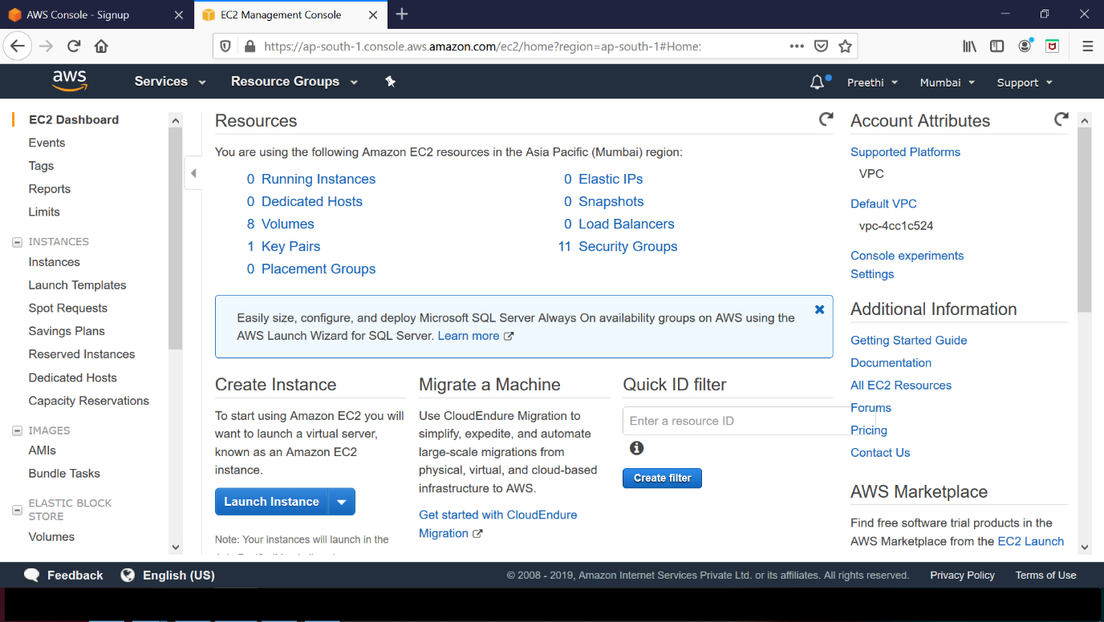

**9. Select “Amazon Linux 2 AMI”**

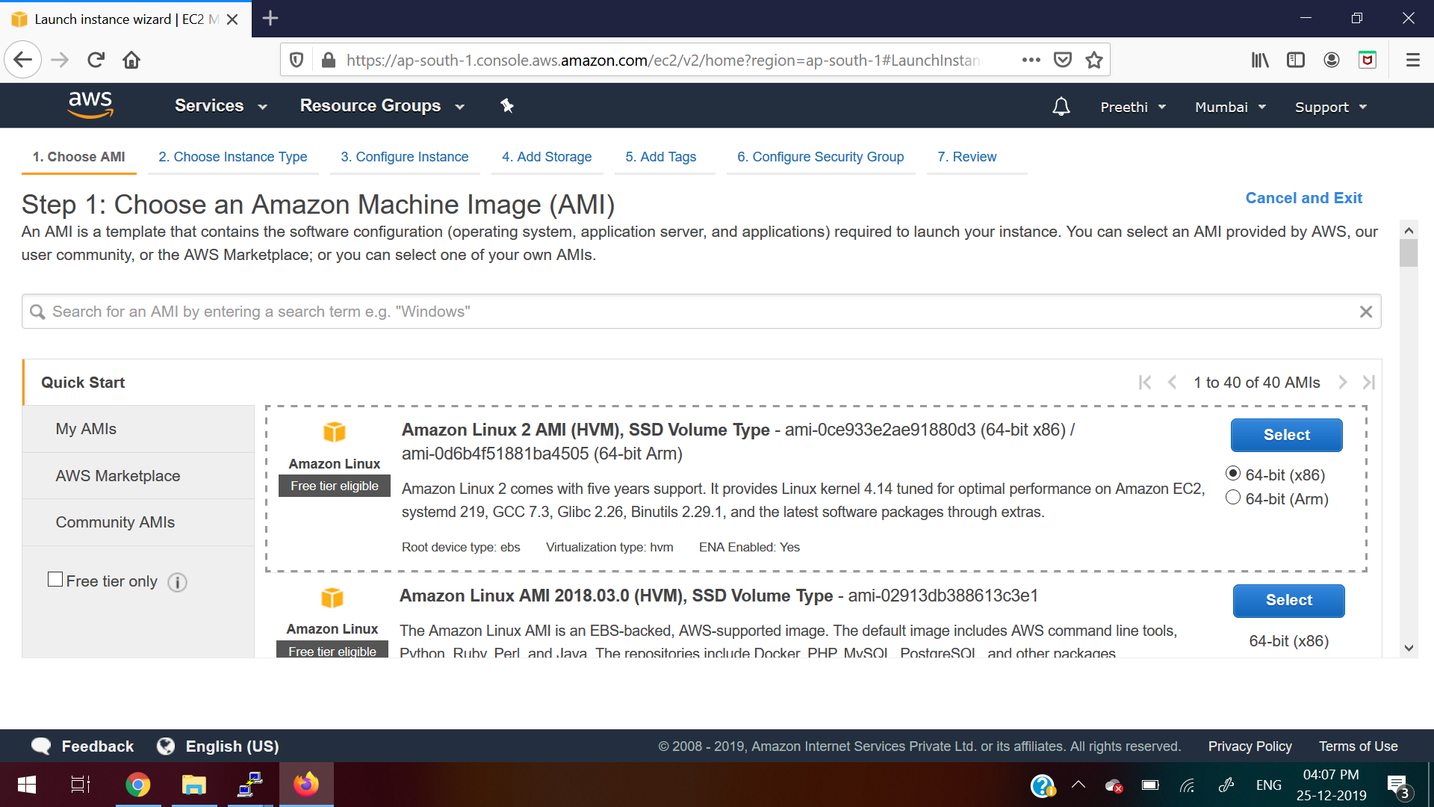

**10. Keep it as default (Don’t do any changes)**

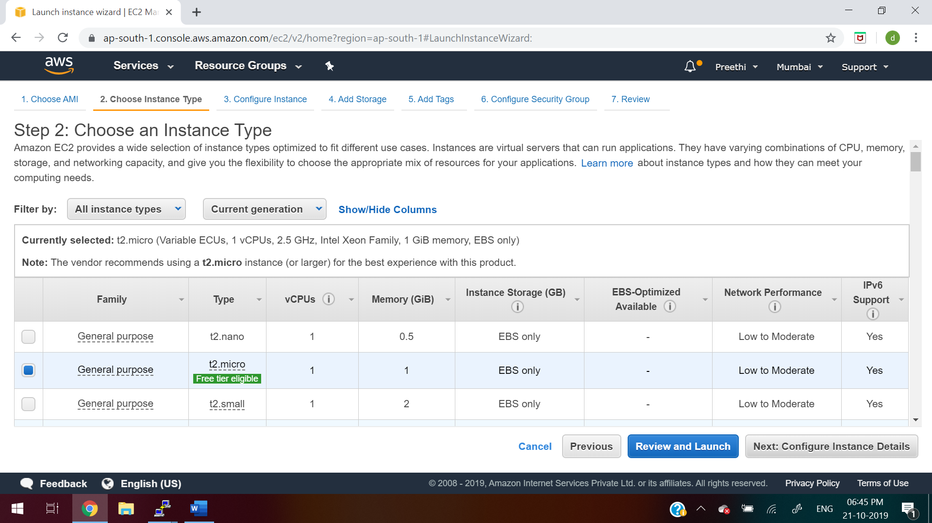

**11. Keep it as default (Don’t do any changes)**

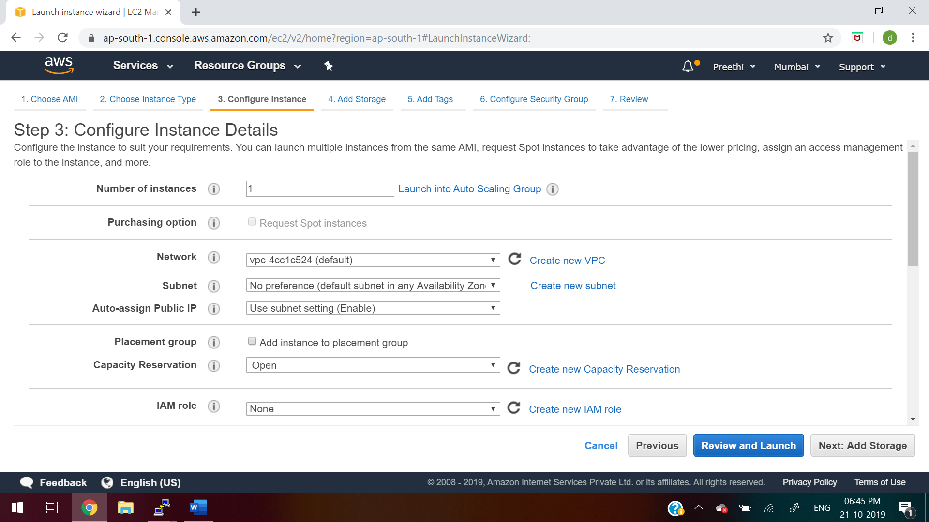

**12. Keep it as default (Don’t do any changes)**

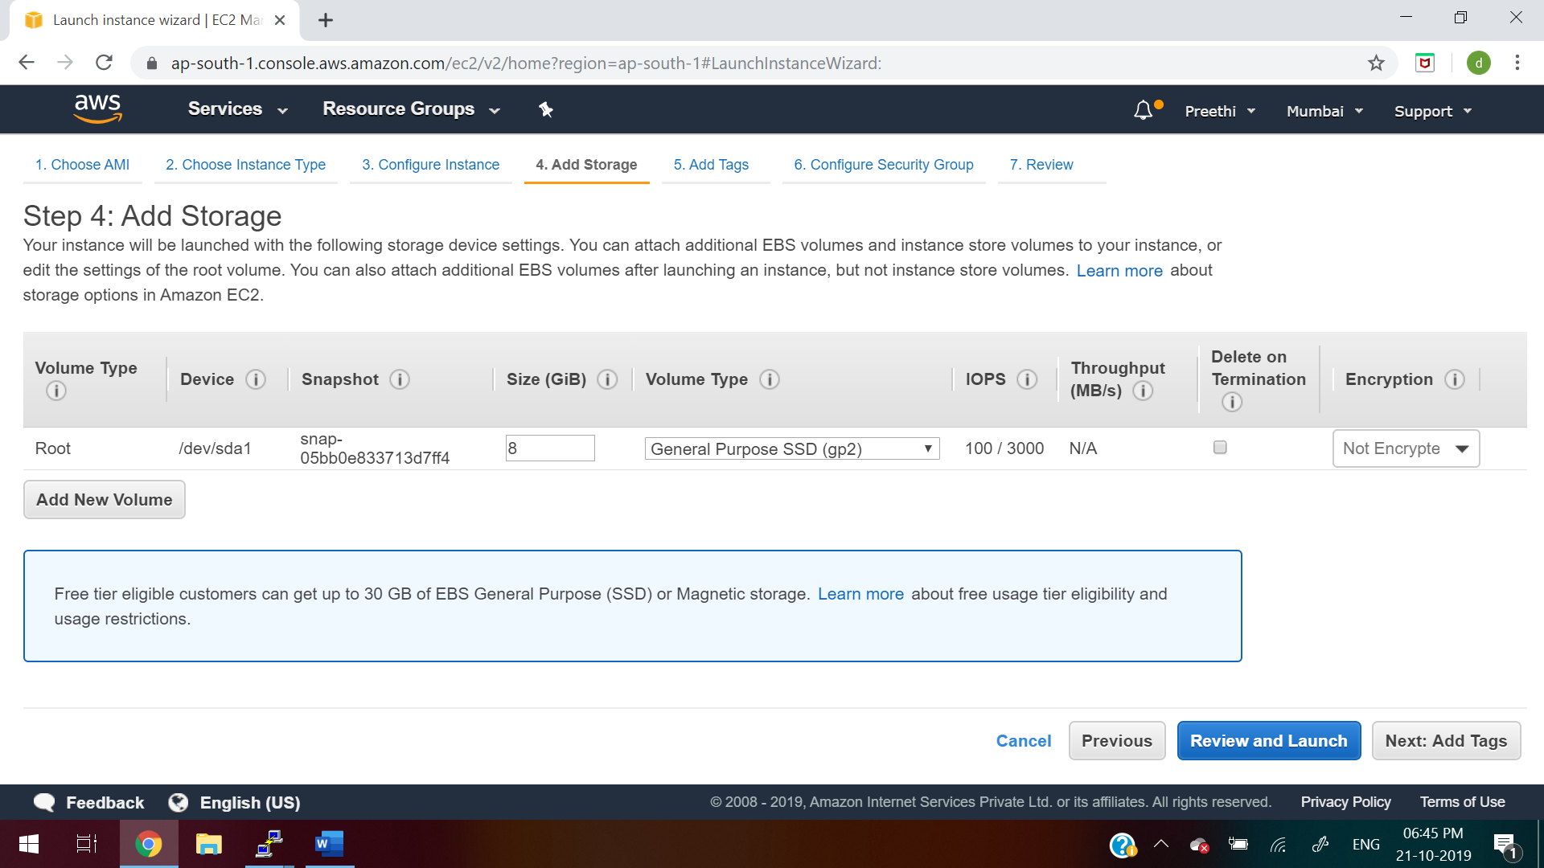

**13. Keep it as default (Don’t do any changes)**

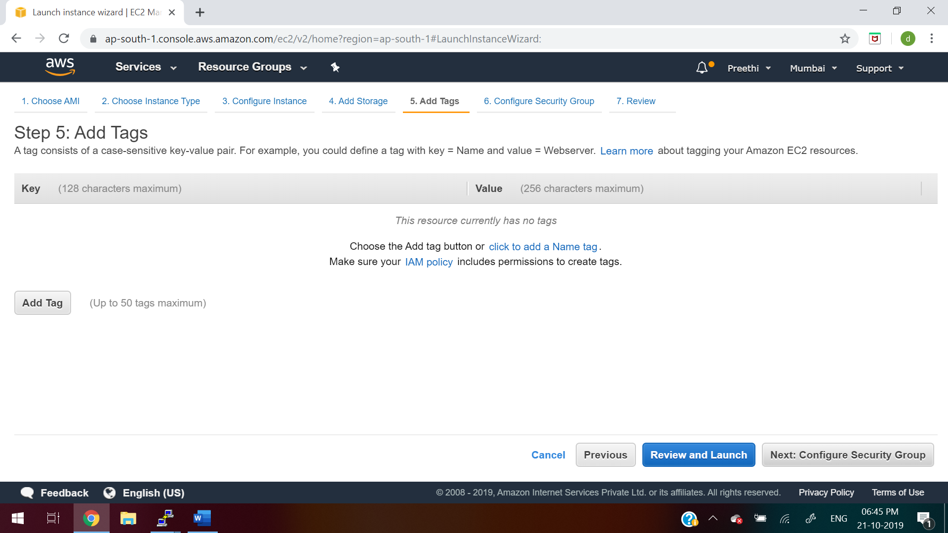

**14. click on “Add Rule” button as below and click on “Review and Launch”**

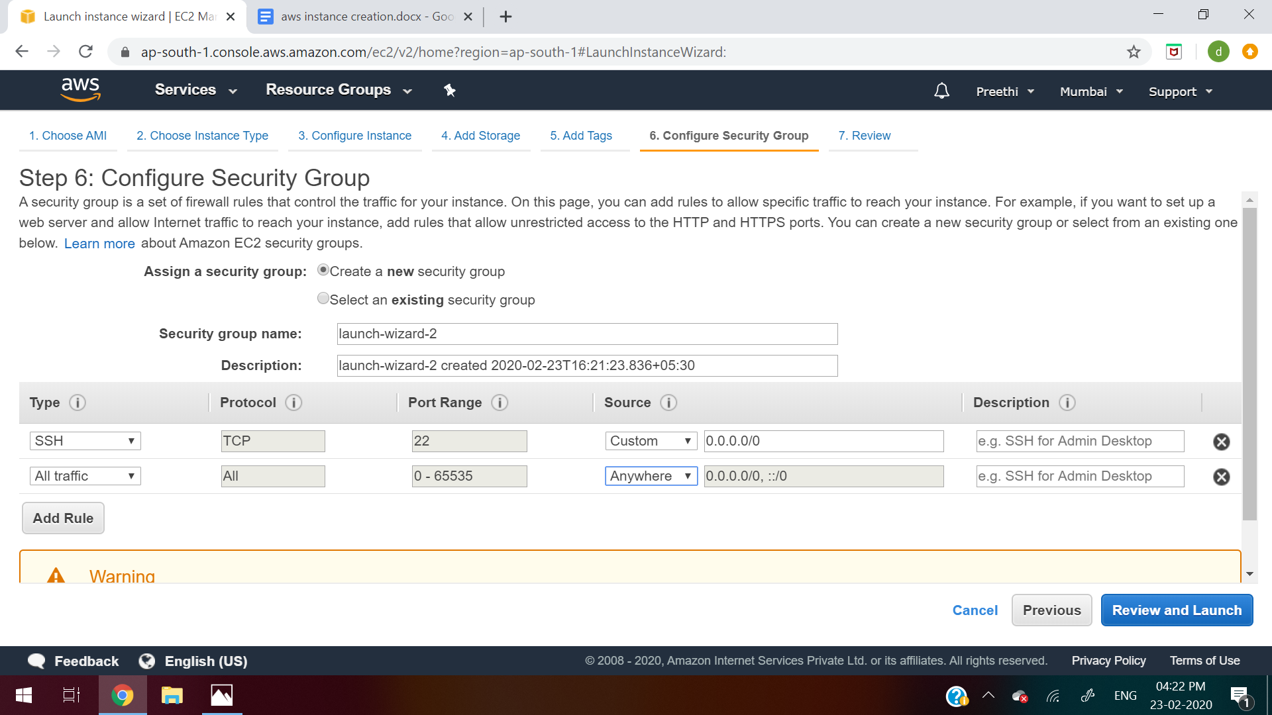

**15. Click on Launch**

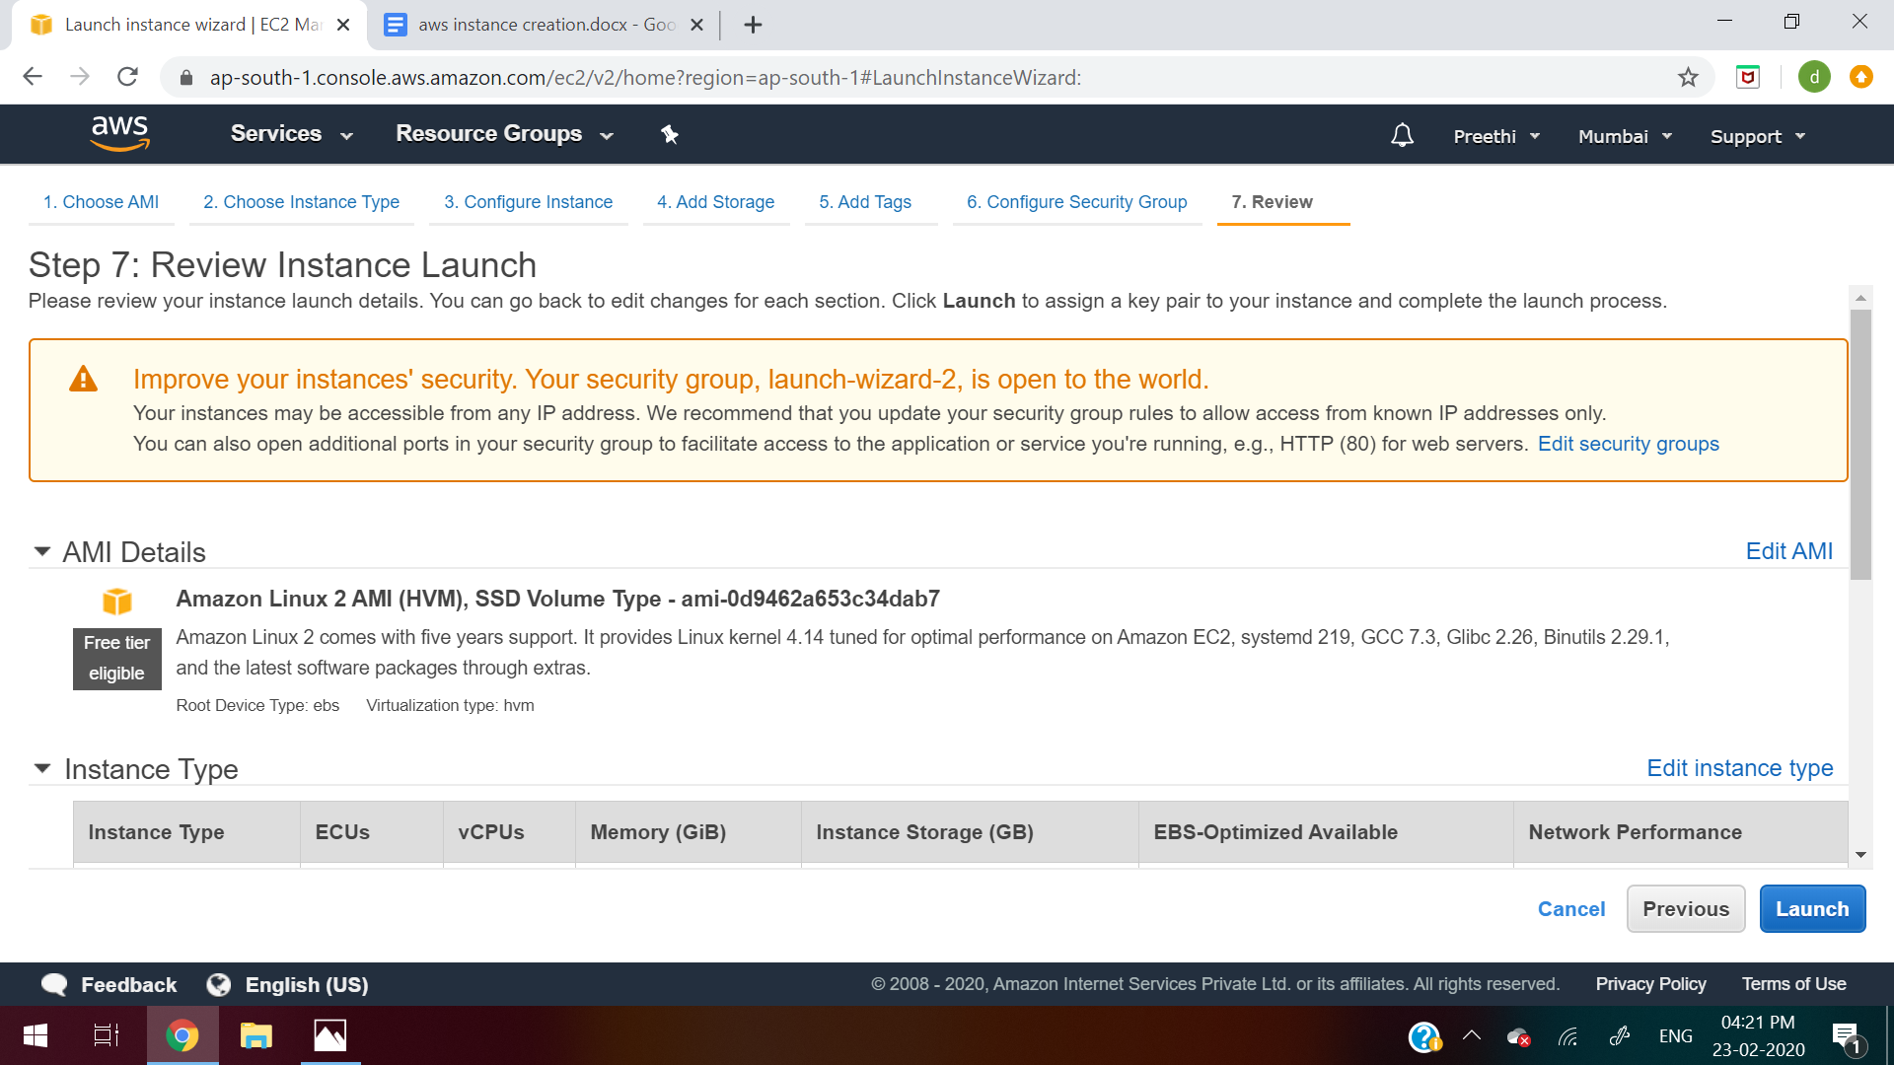

**16. Click on “Create a new key pair”**

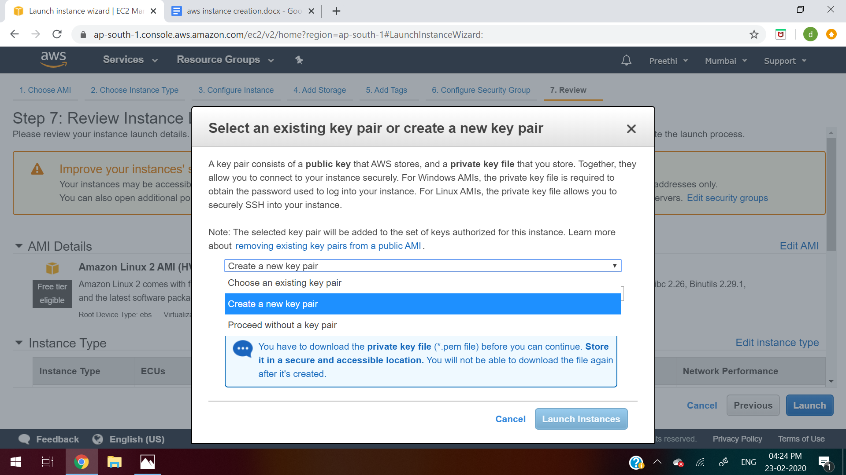

**17.Give some name to the keypair like “aws_key” and then click on “Download the Keypair”**

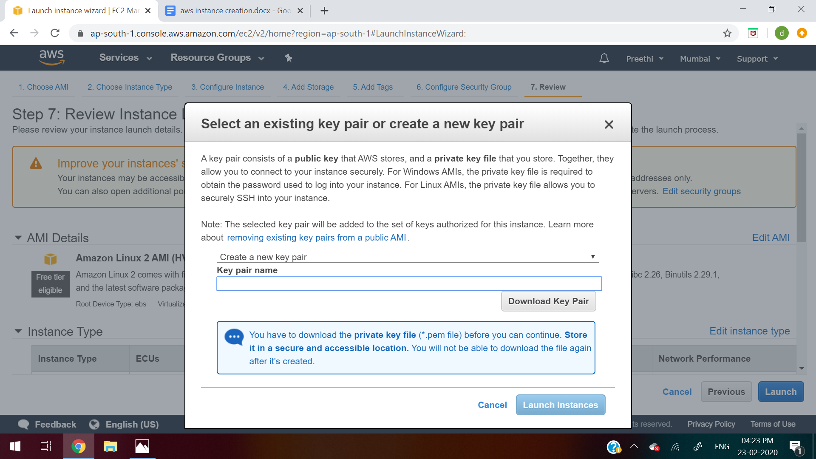

**18. Click on Launch Instance**

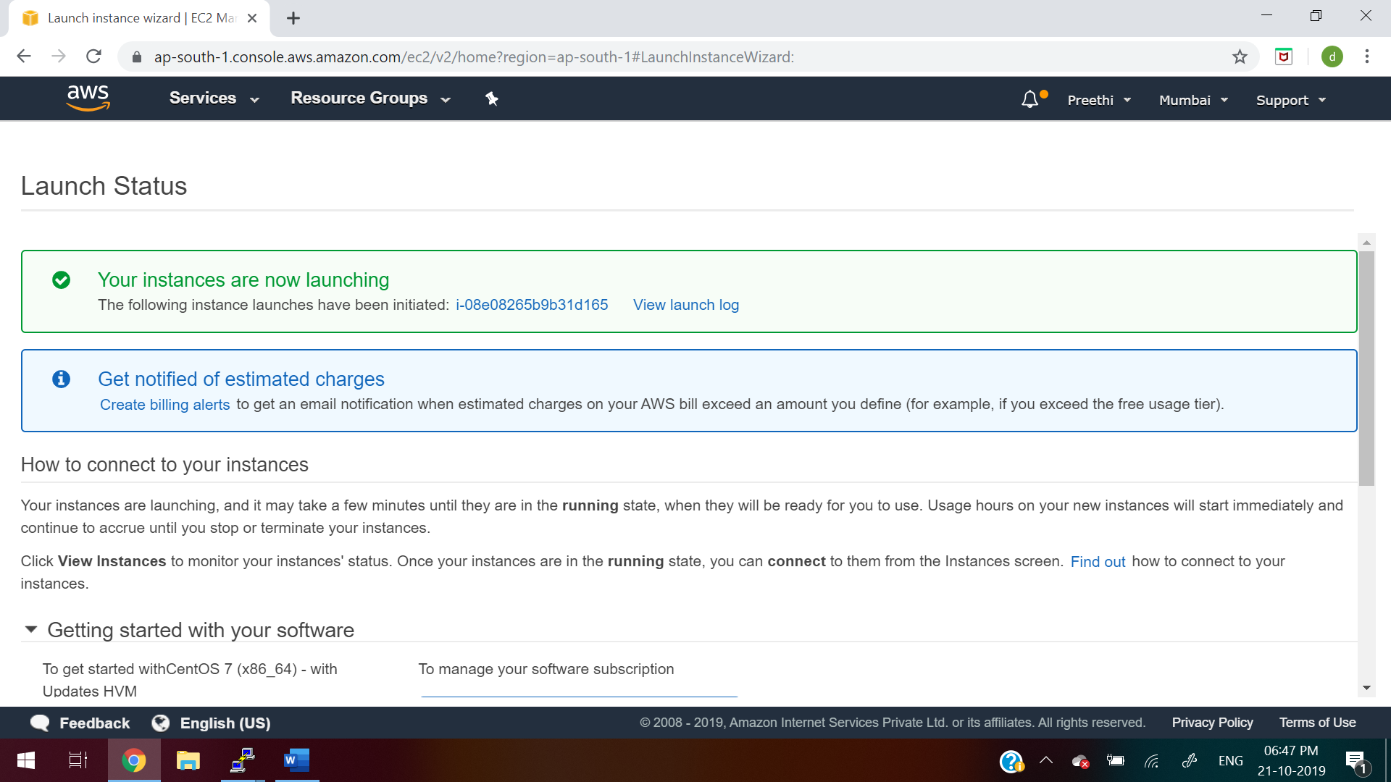

**19.**  **Download Puttygen from** [**https://www.puttygen.com/**](https://www.puttygen.com/)

**20.**  **Click “load” in Putty Key Generator. Select the .pem file from your system downloaded in step 17**

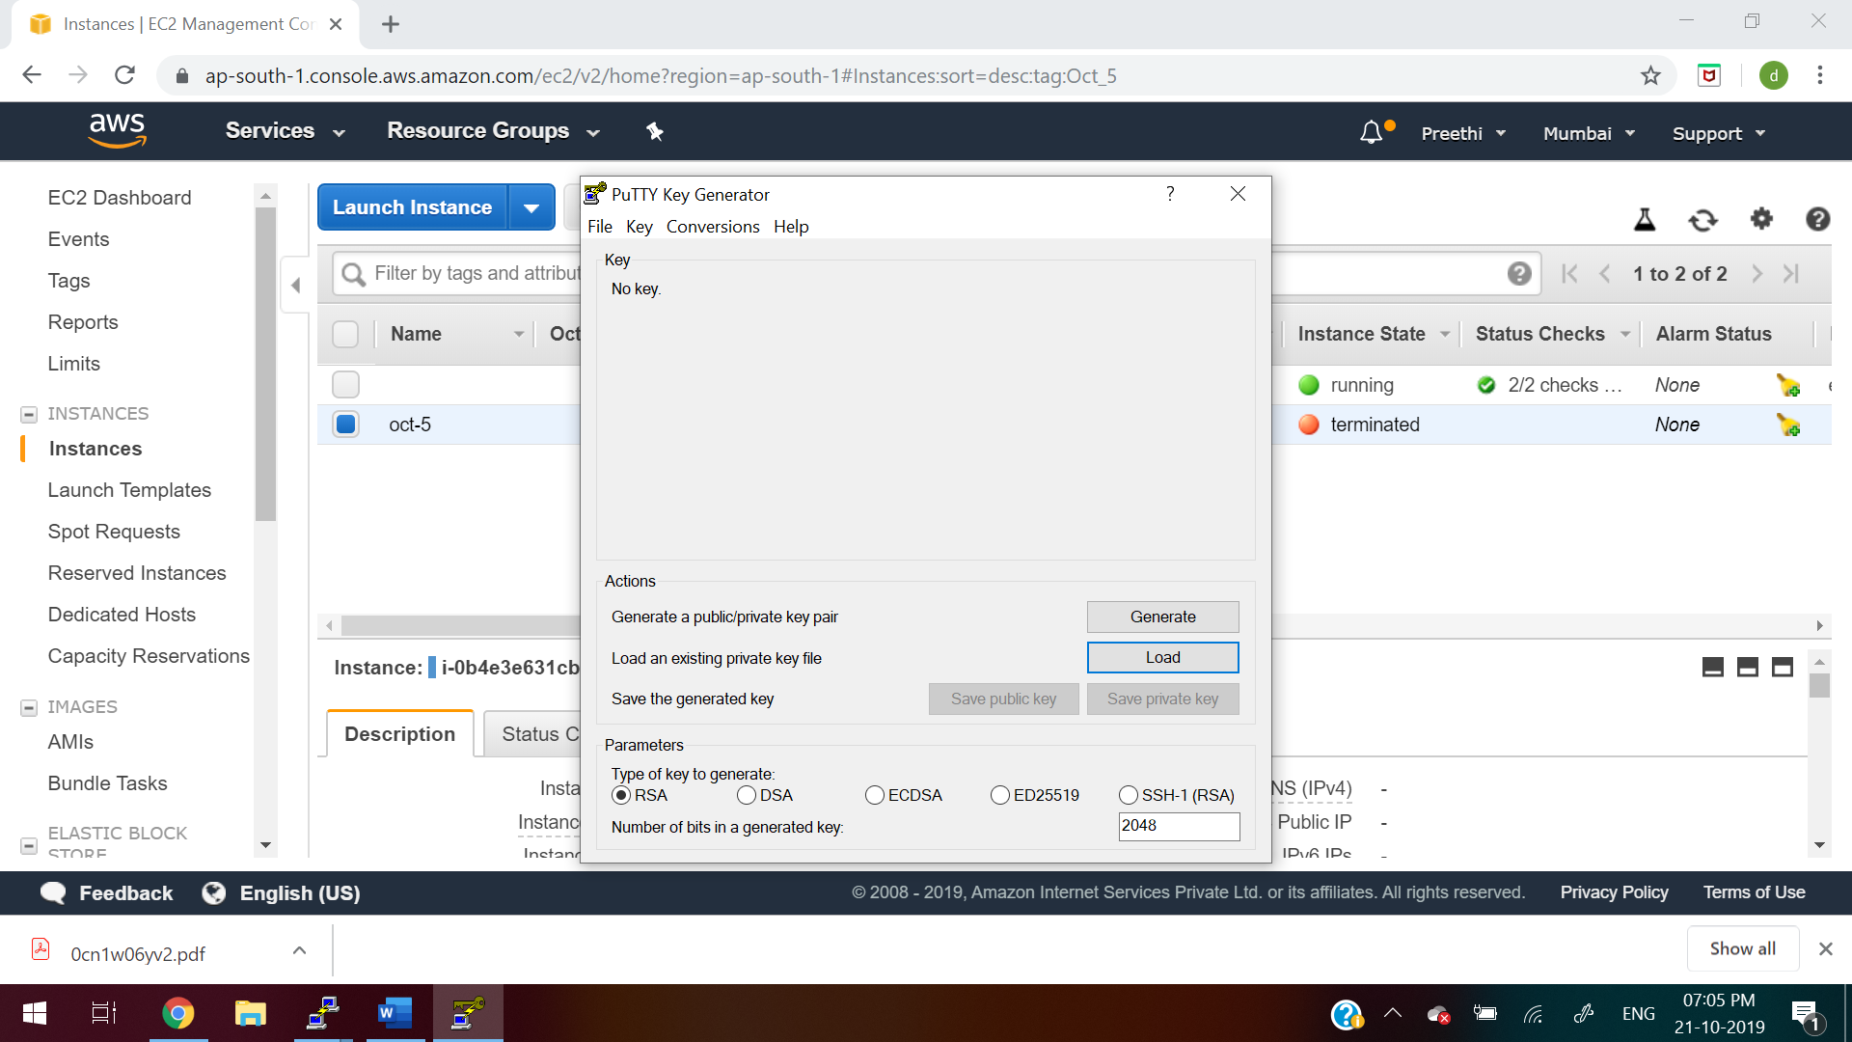

**21. After that, follow the below steps:**

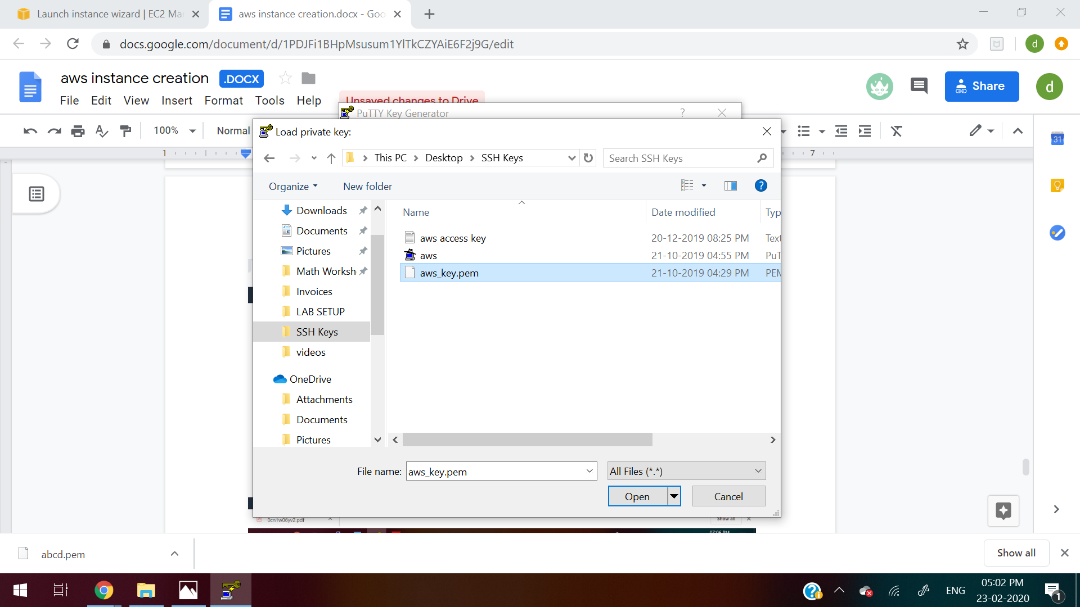

**22. click on “Save private key”. Give name as aws.ppk file**

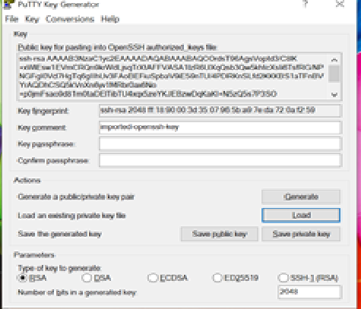

**23. Go to Putty. In the host name, give Public Dns or Public IP**

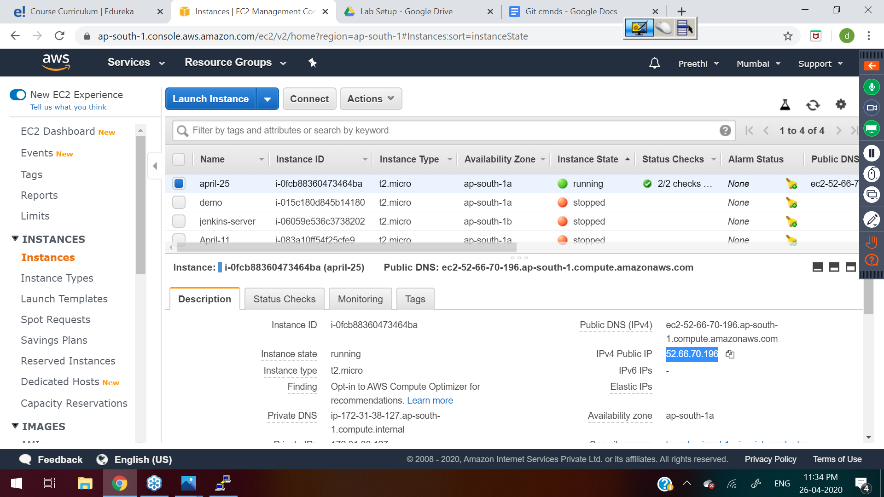

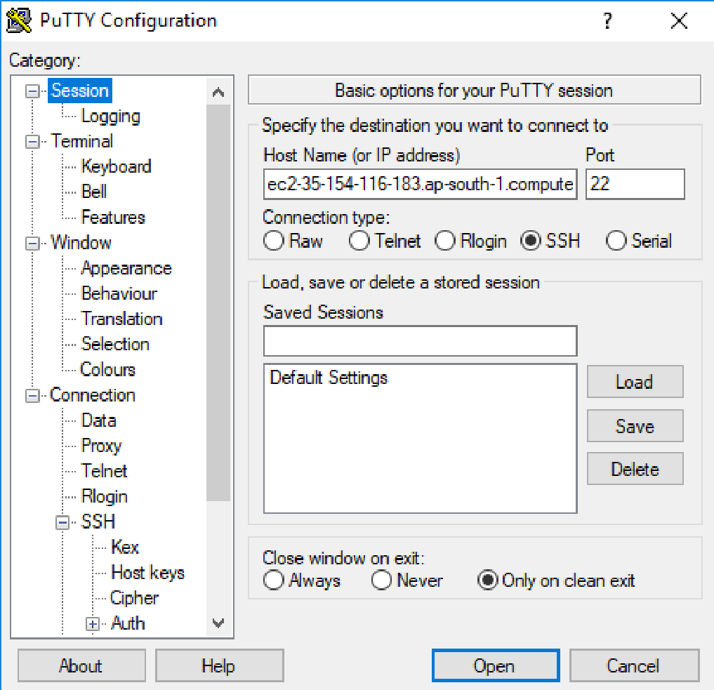

**24. Now go to ssh->auth and browse the aws.ppk file generated in step 22**

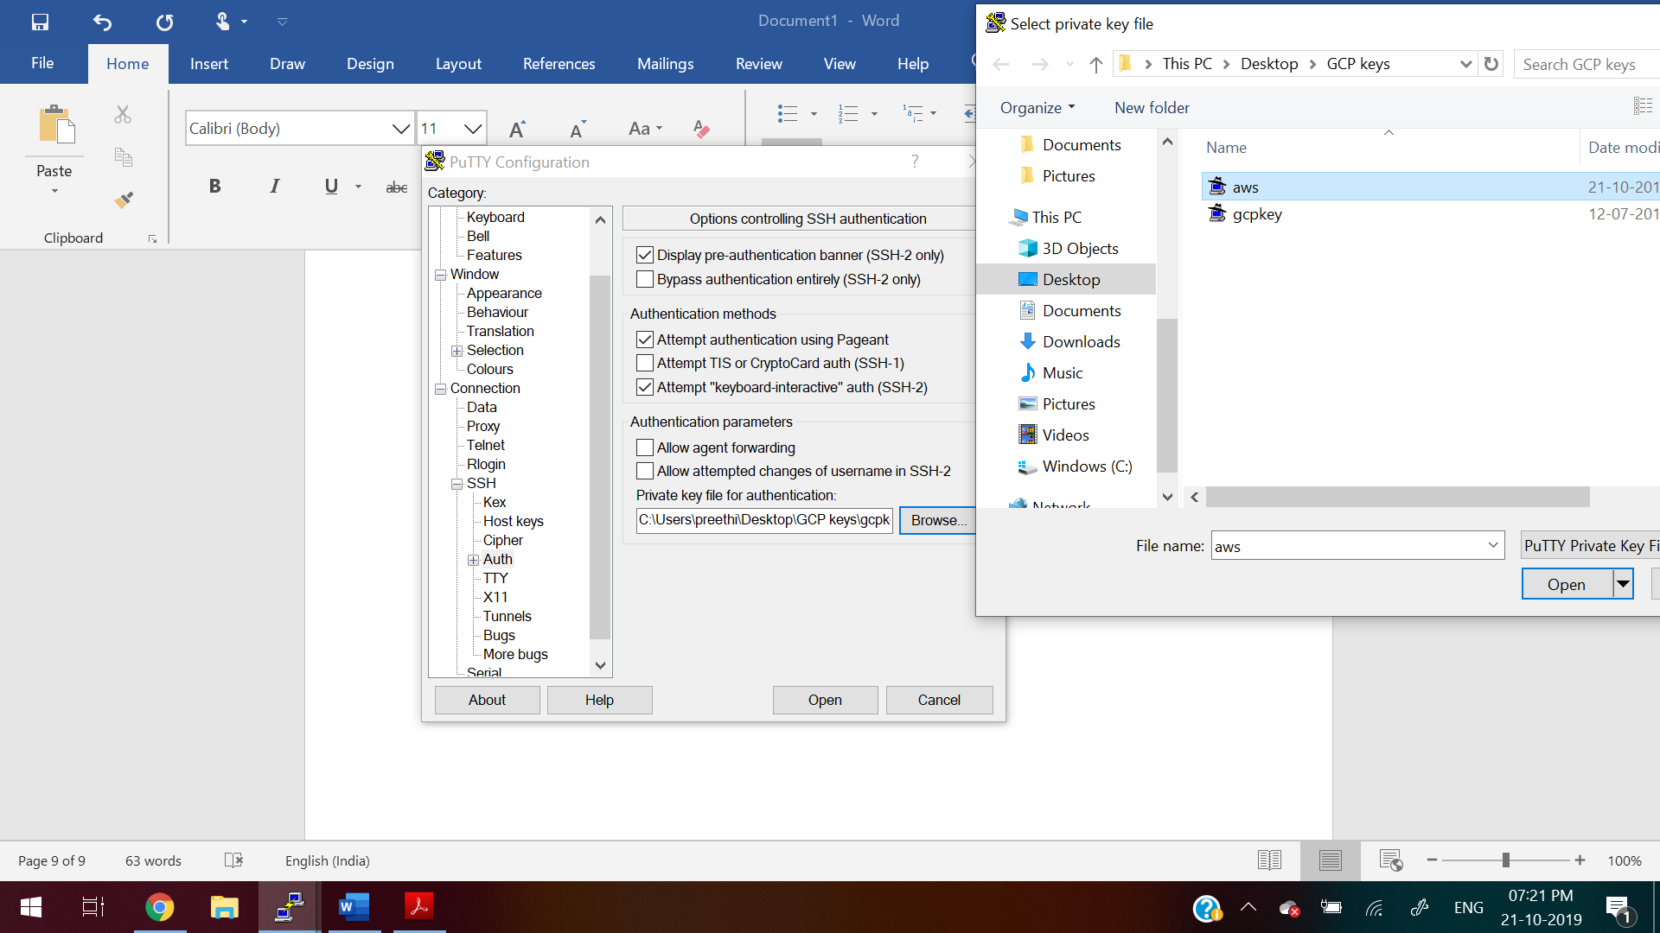

**25.Give the username as “ec2-user” login**

**Then to switch as root user**

**sudo su -**

**For Reference:**

**<https://linuxacademy.com/guide/17385-use-putty-to-access-ec2-linux-instances-via-ssh-from-windows/>**

**<https://docs.aws.amazon.com/AWSEC2/latest/UserGuide/putty.html>**